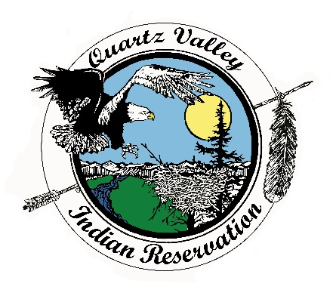
Quartz Valley Indian Reservation

Position Description

Job Title: | Clinic Transporter
Department: | Medical
Primary Location: | Anav Tribal Health Clinic
Classification: | Full Time, Regular, Non-Exempt
Reports to: | Medical Director/Deputy Director
Salary: | DOE

Primary Purpose

The Clinic Transporter will be based out of the Anav Clinic and shall work a set 40 hour per week schedule transporting clinic patients to medical, dental and behavioral health appointments using available Tribal vehicles. The transporter shall provide assistance to patients needing special attention as indicated, (ex; handicapped).

Essential Functions

- Shall efficiently provide transportation for Anav clinic patients to Medical, Dental and Behavioral Health appointments.
- Shall competently provide assistance to patients needing special attention as indicated.
- Shall efficiently and responsibly ensure that all patients comply with State Laws and Tribal Policies (ex; wearing of seat belts, not drinking alcoholic beverages, no smoking, etc.).
- Shall keep accurate documentation of mileage for each trip. Shall keep credit card receipts and turn them in according to QVIR Travel Policy. Shall accurately fill out TMAA logs.
- Shall adequately be responsible for vehicle maintenance including cleanliness.
- Shall be capably available for local and out of the area travel as required for job related training.
- Shall attend all required meetings and functions as requested.
- Is courteous in accepting other job duties as assigned.

Competencies

- Exhibits the ability to work effectively with Native American people in culturally diverse environments.

- Displays the ability to manage time well and work under stressful conditions with an even temperament.

- Demonstrates the ability to establish and maintain harmonious working relationships with other employees and the public.

- Exhibits the ability to understand and follow written and oral instructions.
Other Requirements

- Must be able to pass background check.
- Must adhere to Tribal drug and alcohol policy, including pre-employment drug and alcohol screening.
- Must have a valid driver’s license and insurable under the Tribe’s insurance policy.
- Must be 25 years old or older with clean driving record. Must possess valid driver’s license and be insurable by the Tribe’s insurance carrier.

- One (1) year or more experience working in a customer service industry and/or healthcare related field preferred.

- Knowledge and experience of body mechanics preferred, for assisting disabled persons.

- Must possess a high school diploma /GED or equivalent

- Must strictly adhere to confidentiality and HIPAA policies.

- Must provide documentation of immunity to measles and rubella or become immunized with the recommended vaccine, Flu and Hepatitis B vaccine. Must test annually for TB.

- Must become certified within 90 days of employment in and remain current in CPR and first aid.

- Must successfully pass a pre-employment drug and alcohol screening test and be willing to submit to a criminal background check.

Receipt and Acknowledgment
- The contents of this job description are job requirements, and, at this time, I know of no limitations that would prevent me from performing these functions with or without accommodation. I further understand that it is my responsibility to inform my supervisor at any time that I am unable to perform these functions.
- Job duties, tasks, work hours and work requirements are subject to change.
- Acceptable job performance includes execution of essential functions while maintaining professional conduct and compliance with all QVIR polices, including, but not limited to: QVIR Personnel, Travel, Fiscal, and Purchasing Policy.

Indian Preference:
In accordance with CFR 25, Part 276 and in accordance with Title VII of the Civil Rights Act, Section 701(b) and 703(i), preference in filling all vacancies will be given to qualified American Indian candidates.

Veteran Preference:
In accordance with QVIR Personnel Policy, applicants with documented Veteran status (such as DD-214) will be given preference in filling vacancies.

For questions regarding this position description, including applications, please contact Quartz Valley Indian Reservation Human Resources at 530-468-5907 or humanresources@qvir-nsn.gov

Employee signature below constitutes employee's understanding of the essential functions, competencies, and requirements of the position.

Print Name |  | Signature |  | Date

Approved

Business Council  or  Health Board |  | Signature |  | Date

